Aim: To use Amazon Rekognition to perform object detection in images.
Theory:
- Amazon Rekognition:
A fully managed AWS computer vision service that can identify objects, people, text, scenes, and activities in images and videos using deep learning models.
- Object Detection:
The process of locating and labeling objects within an image. Rekognition returns labels with confidence scores that represent the likelihood of correctness.
- Key Functions in Rekognition:
- detect_labels() – Detects objects, scenes, and concepts.
- detect_faces() – Detects faces and facial attributes.
- detect_text() – Detects printed or handwritten text in images.

Applications:
- Security and surveillance
- Retail analytics
- Autonomous systems
- Media content moderation

Procedure:
Step 1: Launch a SageMaker Notebook Instance
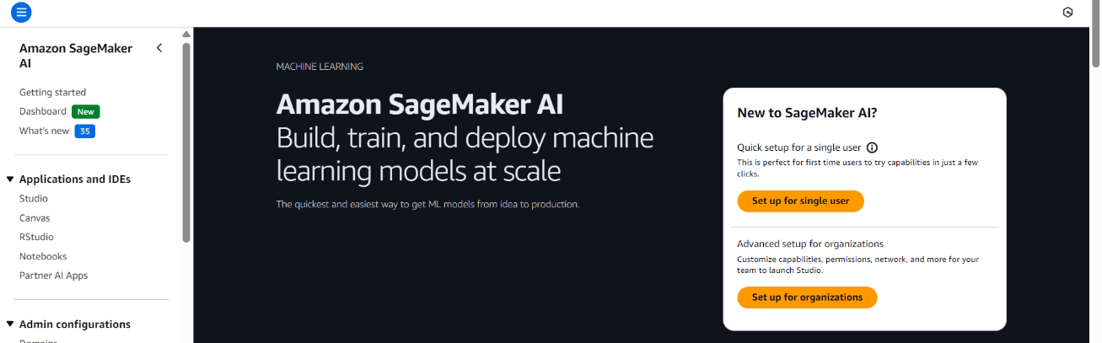
- Open the AWS Management Console and navigate to Amazon SageMaker.

- Create a new Notebook Instance (e.g., data-preprocessing-lab).
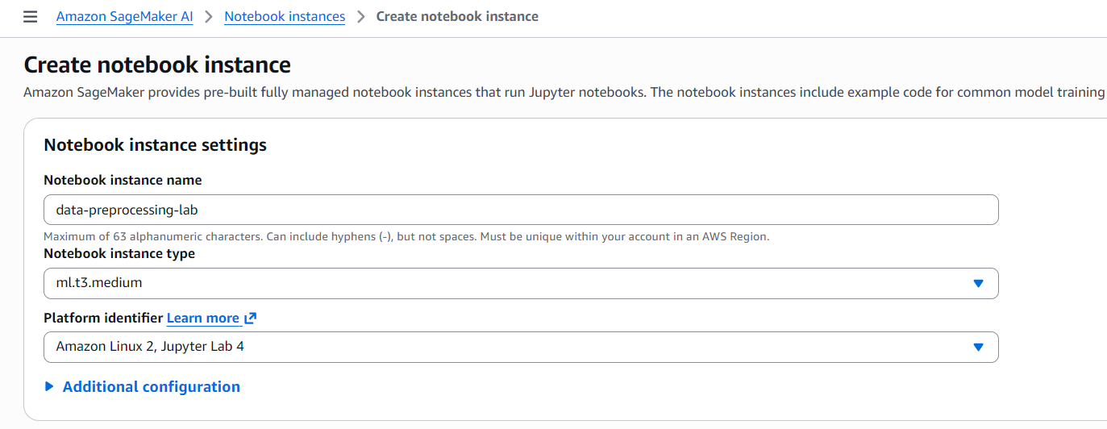
- Choose instance type ml.t3.micro (cost-efficient for small datasets).

- Create an IAM role with AmazonRekognitionFullAccess AmazonS3FullAccess and attach it.
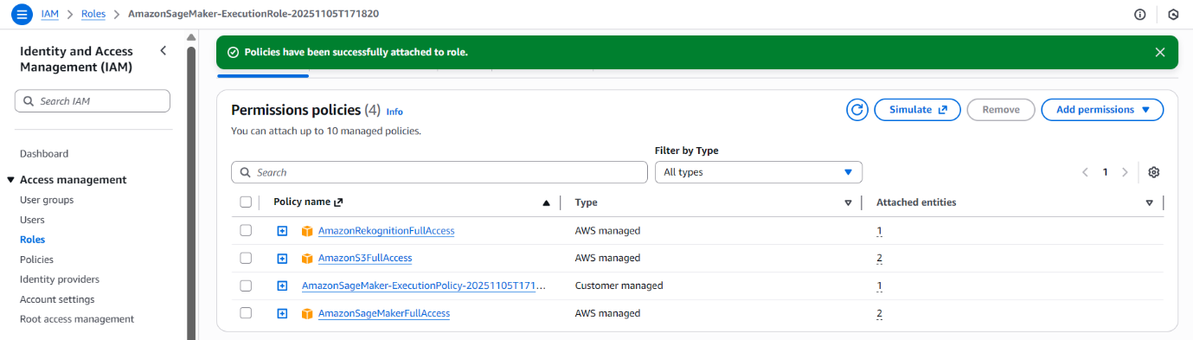

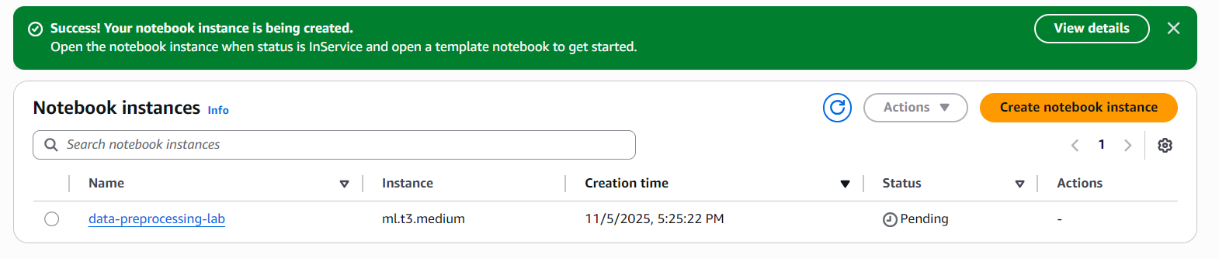
- Once the status is InService, click Open Jupyter to begin.
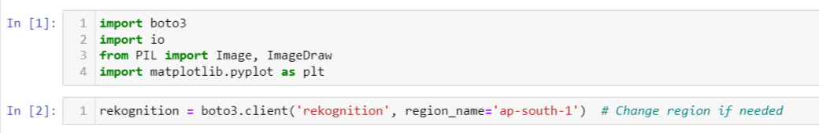
Step 2: Import Required Libraries and Initialize Rekognition Client.

Step 3: Load Image
Step 4: Detect Objects and Scenes
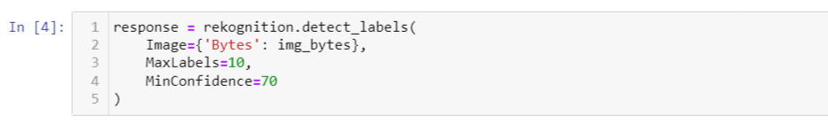
Step 5: Display Detected Labels
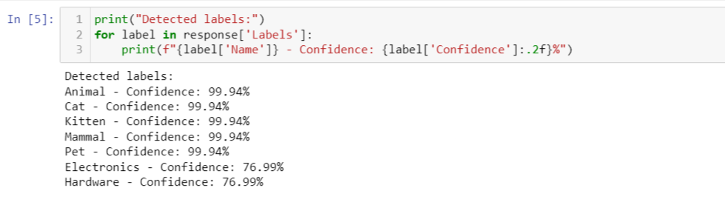

Step 6: Draw Bounding Boxes
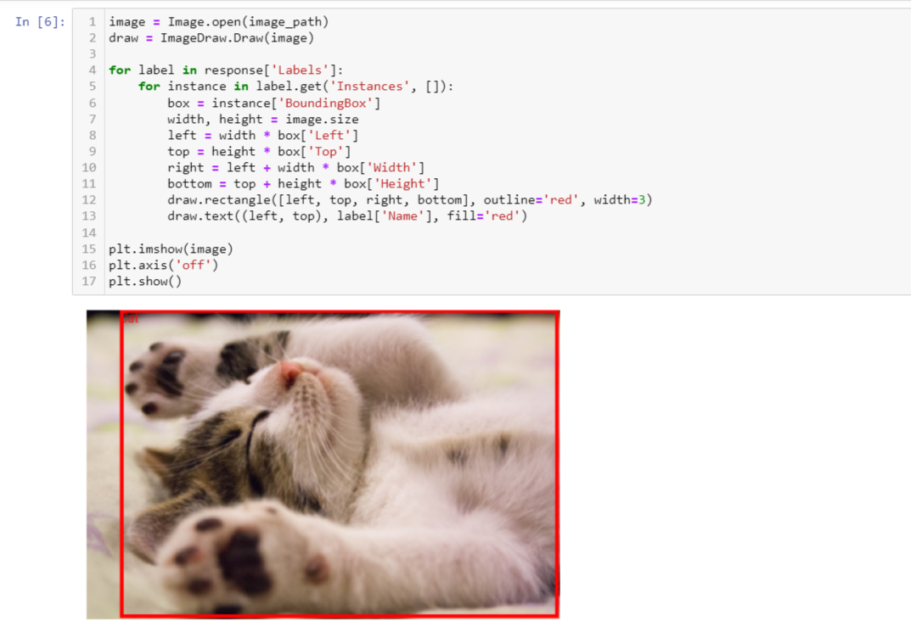
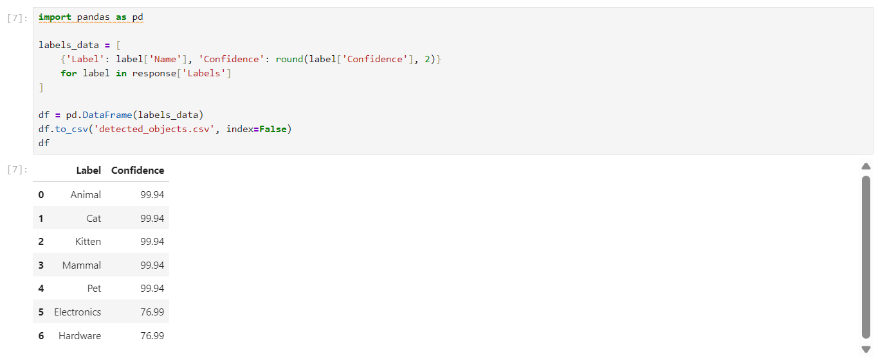
Step 7: Store Results in a CSV
Conclusion:
In this lab, we used Amazon Rekognition to perform object detection on an image.
The service successfully identified multiple objects and scenes, returning confidence scores for each label.
This demonstrated the ease of applying deep learning–based image recognition using AWS cloud services, without the need to train or deploy custom models.
The experiment highlights how Rekognition can be integrated into AI-based applications for security, automation, and image analytics.

